**COMPARATOR RESEARCH ON MARKET**

**1) LM339, LM239, LM139, LM2901 Quad Differential Comparators**

Difference between these models is the range of operating temperature.

LM139: –55°C to +125°C

LM239 and LM239A: –25°C to +85°C

LM339 and LM339A: 0°C to 70°C

LM2901, LM2901AV, and LM2901V: –40°C to +125°C.

Vin range is -0.3V to 36V.

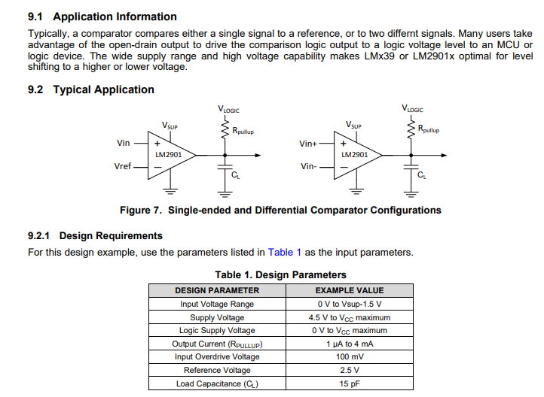

**2) LM393B, LM2903B, LM193, LM293, LM393 and LM2903 Dual Comparators**

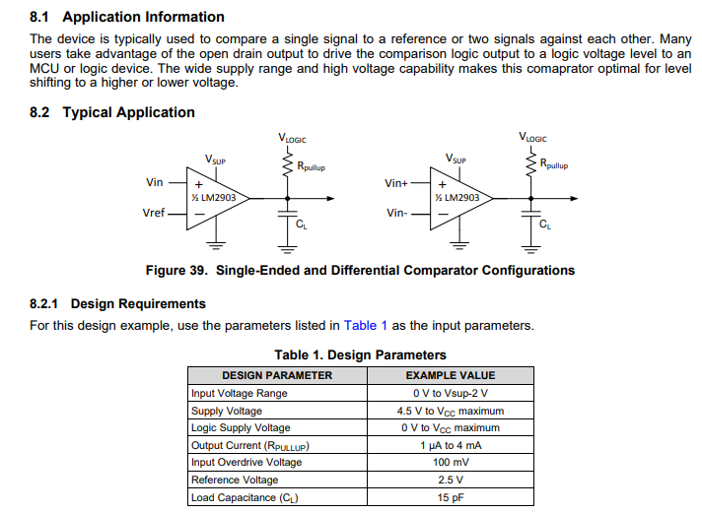

**3) LM111, LM211, LM311 Differential Comparators**

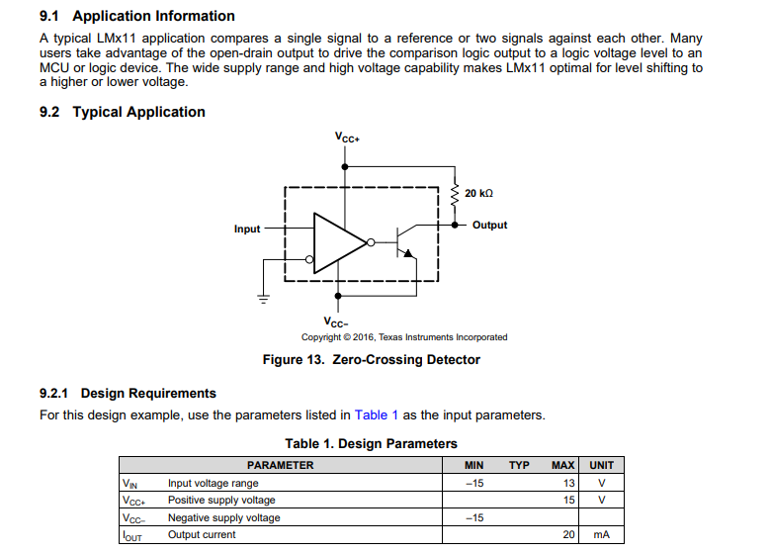

**4) TLC372**

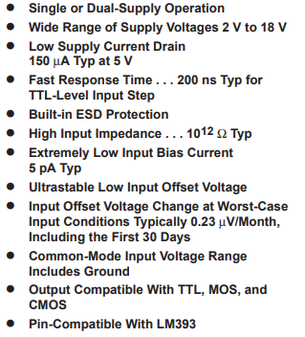

**5) CD54HC85, CD74HC85, CD54HCT85, CD74HCT85 High-Speed CMOS Logic 4-Bit Magnitude Comparator**

